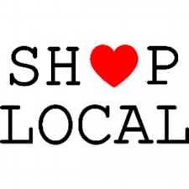
COVID-19 has impacted all our lives
Your veterinary clinic is a locally owned business

Our goal is to provide you and your pet with excellent veterinary service with compassion and the highest standard of care

We ask that you support this goal by continuing to purchse your pet supply needs under the guidance of your veterinary

Ask our qaulified staff about any of the following products:

*Flea & Tick
*Heartworm
*joint supplements
*dog & cat food
*prescription medications
*microchipping

Your Veterinarian is available in an emergency

Ask our staff
Your local Veterianian can offer discounts & rebates

